**The Mobile Money Revolution in Kenya (2007-2025): A Comprehensive Analysis**

**Executive Summary**

This report analyzes the remarkable growth of mobile money services in Kenya from 2007 to 2025, based on monthly data tracking active agents, registered accounts, and transaction metrics. The analysis reveals one of the world's most successful financial inclusion initiatives, with consistent growth across all metrics and fascinating patterns that illuminate Kenya's digital financial transformation.

**1. Overview: Exceptional Growth Across All Metrics**

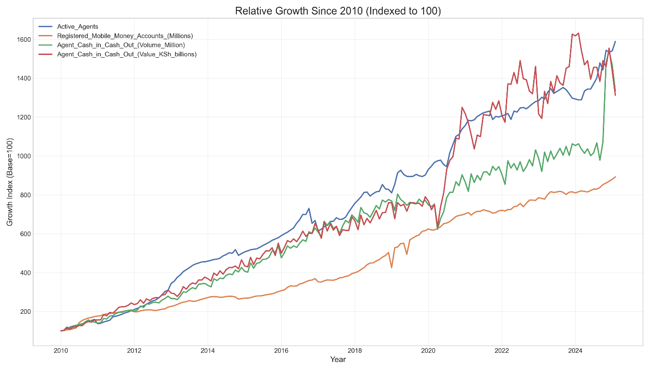*Figure 1: Relative Growth Since 2010 (Indexed to 100)*

Figure 1 illustrates the extraordinary growth trajectory of Kenya's mobile money ecosystem since 2010. All four key metrics have grown by approximately 13-16x their 2010 values:

* **Active Agents** (blue line) grew over 15x, demonstrating massive infrastructure expansion
* **Registered Mobile Money Accounts** (orange line) increased nearly 9x, showing widespread adoption
* **Transaction Volume** (green line) expanded 15x, indicating growing usage frequency
* **Transaction Value** (red line) grew over 13x, reflecting increasing economic significance

The growth patterns show several notable phases:

1. **2010-2014**: Rapid, relatively uniform growth across all metrics
2. **2015-2019**: Continued steady expansion with agent growth outpacing other metrics
3. **2020-2023**: Post-COVID acceleration, especially in transaction value
4. **2024-2025**: Recent volatility with some metrics showing possible consolidation

**2. Infrastructure Development: The Agent Network**

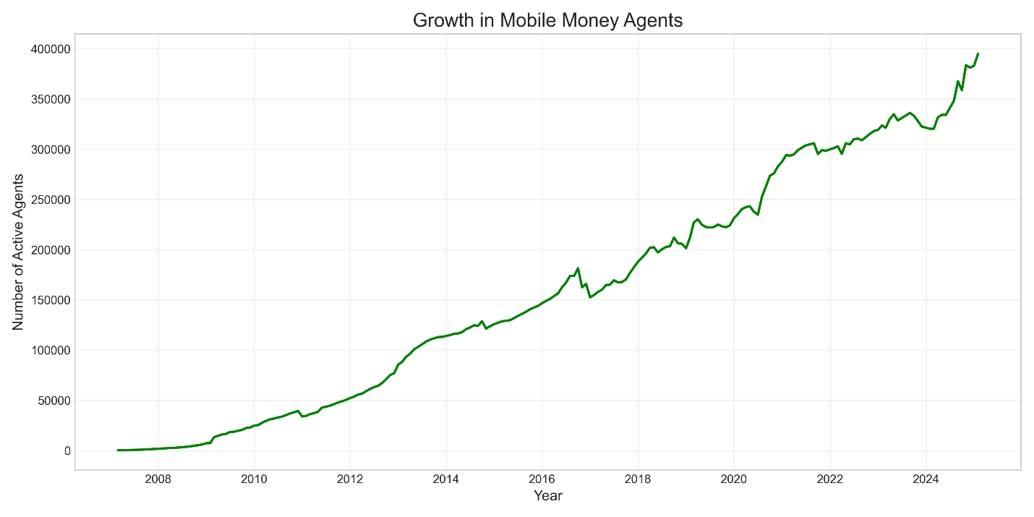*Figure 2: Growth in Mobile Money Agents (2007-2025)*

The foundation of Kenya's mobile money success has been its extensive agent network. Figure 2 shows the remarkable expansion from fewer than 1,000 agents in 2007 to approximately 400,000 by early 2025.

Key observations:

* **2007-2012**: Initial slow growth during system establishment
* **2012-2016**: Accelerated expansion as the model proved successful
* **2016-2018**: Brief plateau suggesting market consolidation
* **2019-2020**: Renewed growth coinciding with pandemic needs
* **2023-2025**: Final surge reaching nearly 400,000 agents

This infrastructure development ensured that most Kenyans gained access to financial services within walking distance of their homes, addressing a fundamental barrier to financial inclusion.

**3. User Adoption: Account Registration Growth**

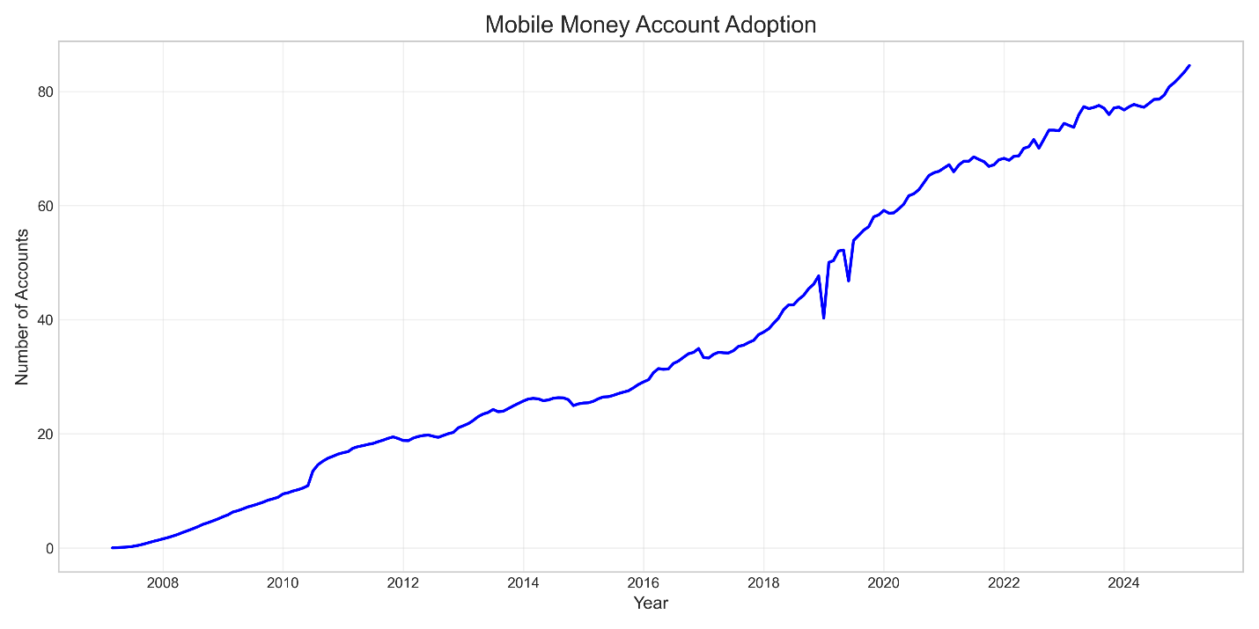*Figure 3: Mobile Money Account Adoption (2007-2025)*

Figure 3 tracks registered mobile money accounts, showing growth from near zero to over 80 million accounts by 2025. With Kenya's population at approximately 55 million, this suggests widespread multi-account ownership across different service providers.

The adoption curve reveals:

* **2007-2010**: Early adoption phase with modest growth
* **2010-2016**: Steady expansion as the service gained mainstream acceptance
* **2017-2020**: Accelerated growth possibly driven by increased use cases
* **2020-2025**: Continued growth with possible market saturation approaching

The impressive 58.93% CAGR for account registration over this period highlights how mobile money moved from a novel technology to an essential service for most Kenyans.

**4. Transaction Metrics: Volume and Value Growth**

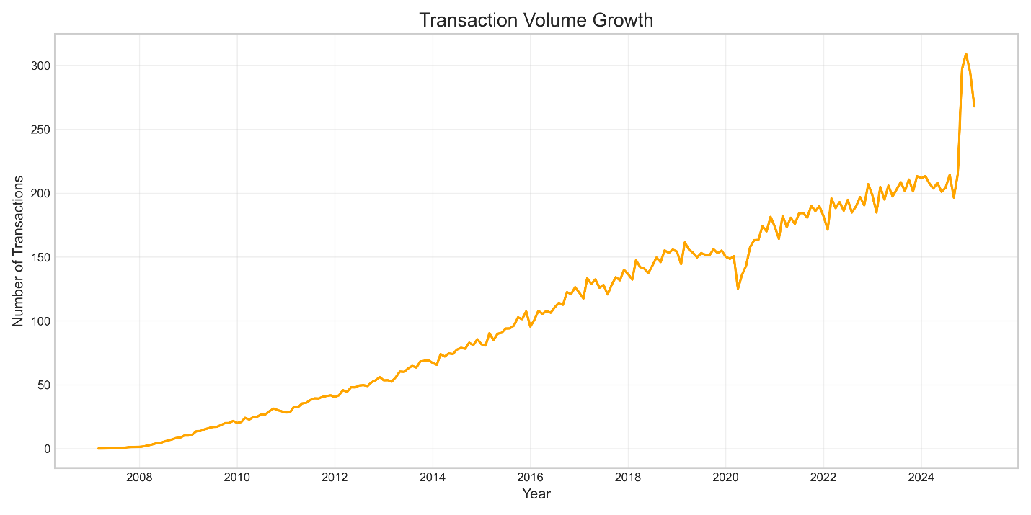*Figure 4: Transaction Volume Growth (2007-2025)*

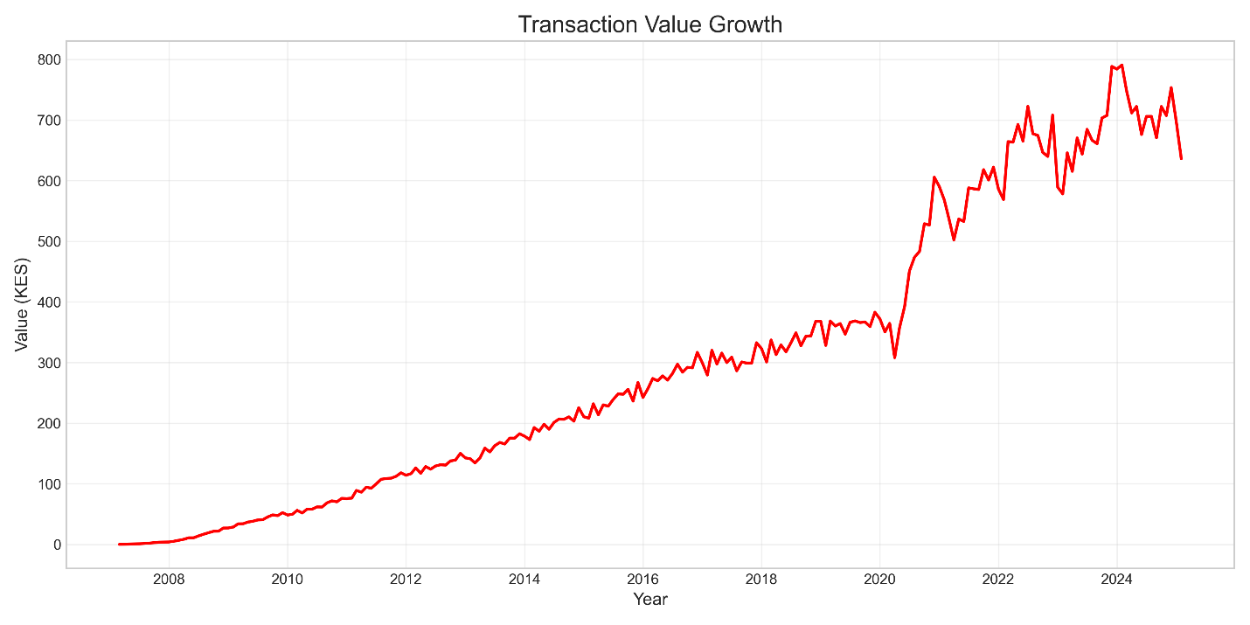*Figure 5: Transaction Value Growth (2007-2025)*

Figures 4 and 5 display the growth in transaction volume and value, respectively. These metrics most directly reflect how actively Kenyans use mobile money services in their daily lives.

Transaction volume (Figure 4) shows:

* Steady growth from 2007-2023
* A dramatic spike in early 2025, reaching over 300 million transactions
* This recent surge suggests either a significant policy change, new use cases, or possible data reporting changes

Transaction value (Figure 5) demonstrates:

* Consistent growth throughout the period
* An inflection point around 2020 (COVID-19 pandemic)
* Growth to approximately 650-750 KSh billions by 2024
* A slight decline in the most recent period

The comparison between these charts reveals that while both metrics grew substantially, their patterns diverged at times, suggesting changes in average transaction size as the system matured.

**5. Ecosystem Integration: Correlation Between Metrics**

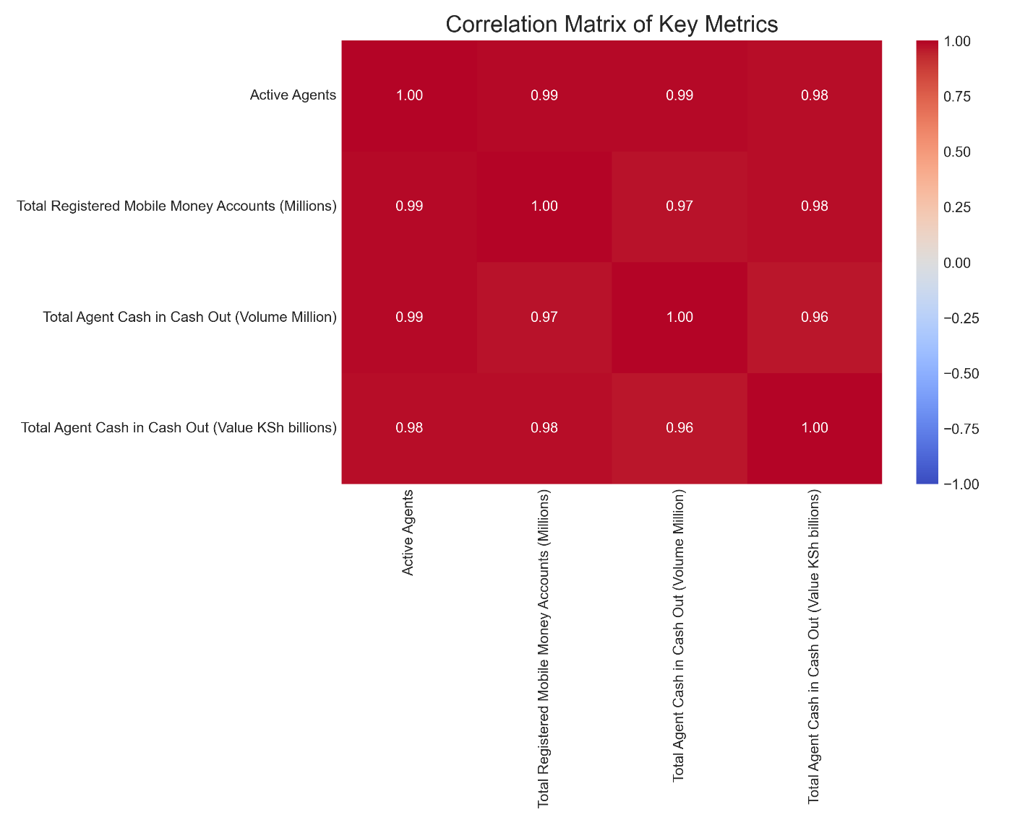*Figure 6: Correlation Matrix of Key Metrics*

Figure 6 presents a correlation matrix showing the relationships between all four key metrics. The uniformly high positive correlations (≥0.96) reveal a tightly integrated ecosystem where infrastructure growth, user adoption, and actual usage expanded in remarkable harmony.

This balanced development suggests:

* Effective market coordination between supply (agents) and demand (users)
* Absence of major bottlenecks in any single area
* Well-matched expansion of capacity and utilization

Such high correlations are unusual in rapidly growing systems and speak to the well-orchestrated development of Kenya's mobile money ecosystem.

**6. Seasonal Patterns: Annual Usage Cycles**

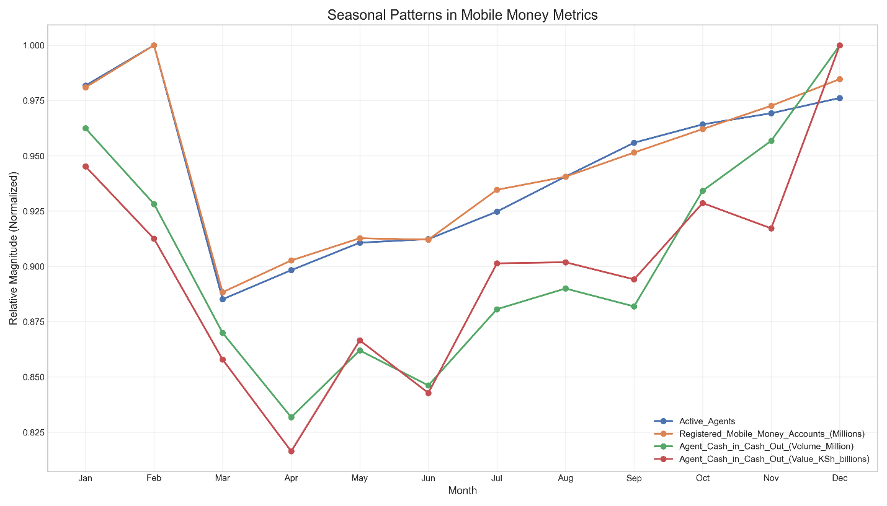*Figure 7: Seasonal Patterns in Mobile Money Metrics*

Figure 7 illustrates clear seasonal patterns across all metrics, demonstrating how mobile money usage fluctuates throughout the calendar year:

* **Peak periods**: December, January, February
* **Tough periods**: March, April, June
* **Recovery periods**: July through November

These patterns likely reflect:

1. Higher financial activity during end-of-year holidays
2. Financial constraints in April (possibly related to the April holiday break as most schools in Kenya typically close for a break in April)
3. Mid-year slowdown in June (potentially related to individual tax returns since June 30th marks the end of the financial year for the Kenyan Government)

The consistency of these patterns across metrics indicates how deeply embedded mobile money has become in Kenyans' financial lives and annual economic cycles.

**7. Growth Maturation: Slowing but Steady Expansion**

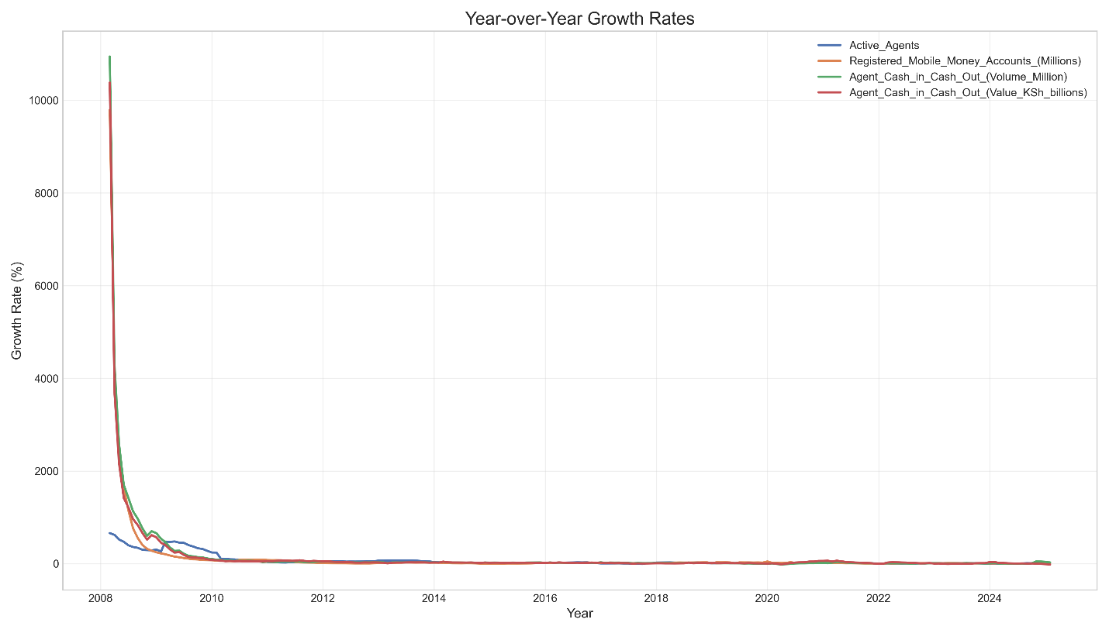*Figure 8: Year-over-Year Growth Rates (2007-2025)*

Figure 8 displays year-over-year growth rates, showing the expected pattern of extremely high initial growth followed by gradual stabilization as the market matures:

* **2007-2010**: Explosive early growth rates (often >1000%)
* **2010-2015**: Rapid but moderating growth
* **2015-2025**: Continued positive but more sustainable growth rates

This pattern is typical of successful technology adoption curves and indicates a maturing ecosystem rather than stagnation. The consistently positive growth rates even in recent years suggest the mobile money revolution continues to expand, albeit at a more measured pace.

**Conclusion: A Transformative Financial Inclusion Success Story**

Kenya's mobile money ecosystem represents one of the world's most successful financial inclusion initiatives. From 2007 to 2025, it transformed from an experimental service to a financial backbone handling hundreds of billions of shillings through hundreds of millions of transactions monthly.

The data reveals not just growth but maturation of a robust ecosystem that has become fundamental to Kenya's economy. The recent transaction volume spike and pandemic-era acceleration in value suggest the system continues to evolve, with potentially new use cases emerging even as the market matures.

Looking forward, while the extremely high growth rates have naturally moderated, the continued upward trajectories across all metrics suggest this financial transformation still has room to expand, particularly in transaction intensity per user and integration with other financial services.

The Kenyan mobile money story offers valuable lessons for other emerging markets seeking to expand financial inclusion through digital means, demonstrating how technology can leapfrog traditional banking infrastructure to create accessible financial services for previously underserved populations.